**TradersGem**: *Simple, Functional, Valuable*.

Luiz Medeiros

Pedro Miranda

**Analysis Phase:**

**Description**

The application includes the ability to follow stocks.Moreover, its allows the user to create watch lists. Here, the user is able to add notes to the stocks and pose it in a priority list. There is also the possibility to see the graphs of the stocks.

With the graphs, you have the chance to see multiple types of curves and graphing styles based on the functions and mathematical models available (ex. MFI, RSI, EMA,etc...).

Furthermore, the app allows the user to create portfolios that offers the options to track the buys, sells and short sells. There is also the ability to track the profits, losses and percentage gains/losses .

Through such features, the user is able to keep track of his/her investments as well make notes,see current market analysis, and make real time decisions on whether to buy or sell a particular holding.

Now, the application will also provides the ability to simulate the stocks based on certain parameters. For example, if you buy and sell for a certain price, what is your profits. Based on current market numbers, is this a buy, hold or sell.

This simulation will be applied through financial mathematical models and algorithms such as the ones mentioned above.

Screening for stock based on given parameters is also a possibility with this application.

Hence, the overall goal of the application is to be able to keep a trader fully informed and educated regarding his current position and probable position on any one current or possible trade. It is to be a tool that will provide valuable information for the trader on the go, so that an opportunity will not be missed and profits may continue to flourish.

**Use Cases:**

**Actors:** Represent

1. Log in the app  
   1. User clicks on the application  
   2. Application launches and inquir­es for log in ID and password  
   3. User enters the information in the fields provided  
   4. Application checks user's credibility  
   5. Verification succeeds, users is presented with the home screen displaying the main portfolio.
2. Screen for Stocks:  
   1. User succeeds in User case #1  
   2. ...
3. Add Portfolio:
4. Add Watch List:
5. Add note to stock:
6. Add stocks to watch list:
7. Add user:
8. Perform simulation on a stock:
9. Add graph analysis to graph:
10. Create simulation model:

**Functional Specifications:**

The application will provide the users the ability to login to their personalaccounts and monitor their portfolios.TradersGem’s target will be an Android application using java for thebackend programming, XML for the GUI design and the Activity class for theconnection between the UI and java interface. This is similar to the swinginterface. The project will also include a SQL Lite database which will be used tosave user accountinformation such as username and password along with sub categories such linked to both. These sub categories are comprised of the apps functionalities such as the results of simulations, watch lists, portfolio, notes and graphs.

The log in will also facilitate an eventual integration with a web platform, such as a larger and more powerful version of the app running on the web.

**Design Phase:**

**CRCs**

The following is the CRCs achieved for the project:







Below is a set of relationship put into tables between the classes and their respective patterns:



**Class Diagrams**

The following is the Class Diagrams achieved for the project:

The Class Diagram below implements the interactions between the classes Simulator, Graph and Stock. The graph implements the MVC pattern as well as the Observer Pattern.

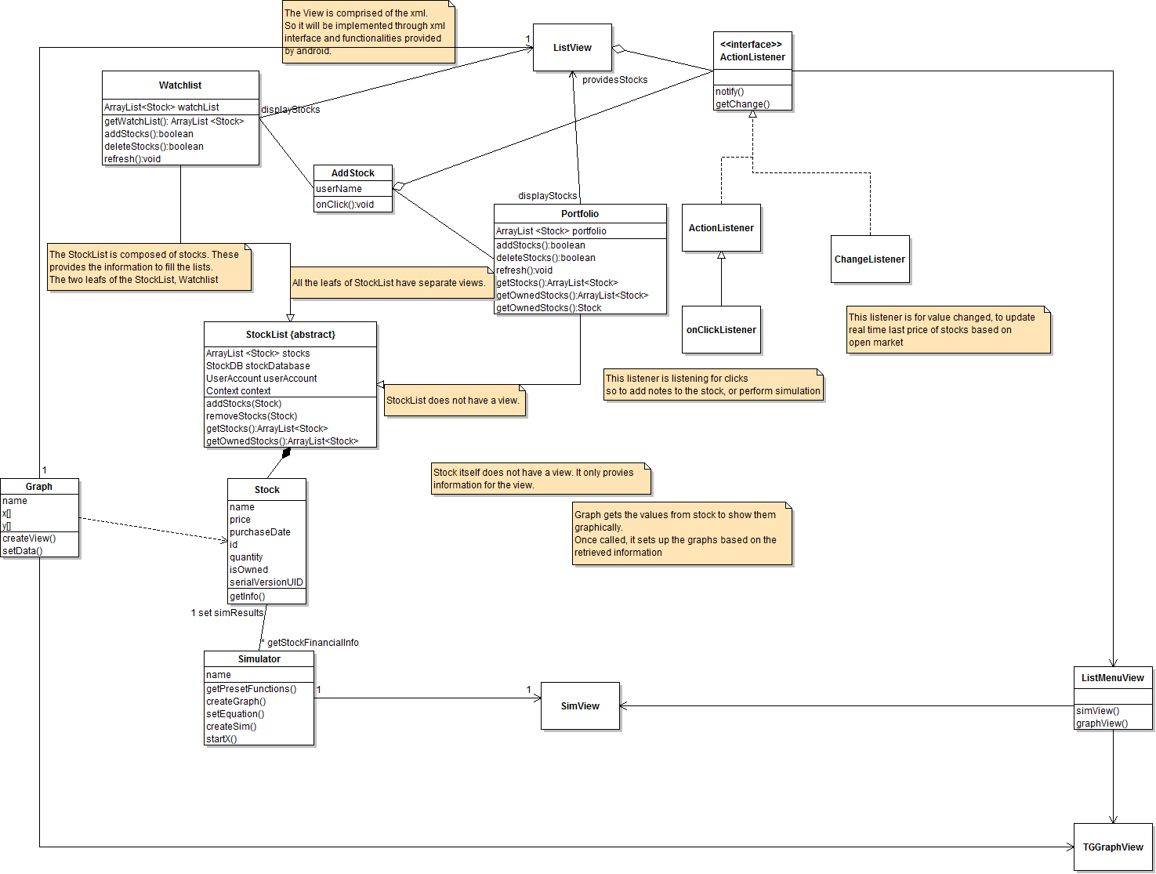

The Class Diagram below implements the interactions between the Database, Stock and Account classes involved in the Strategy Pattern and Iterator Pattern.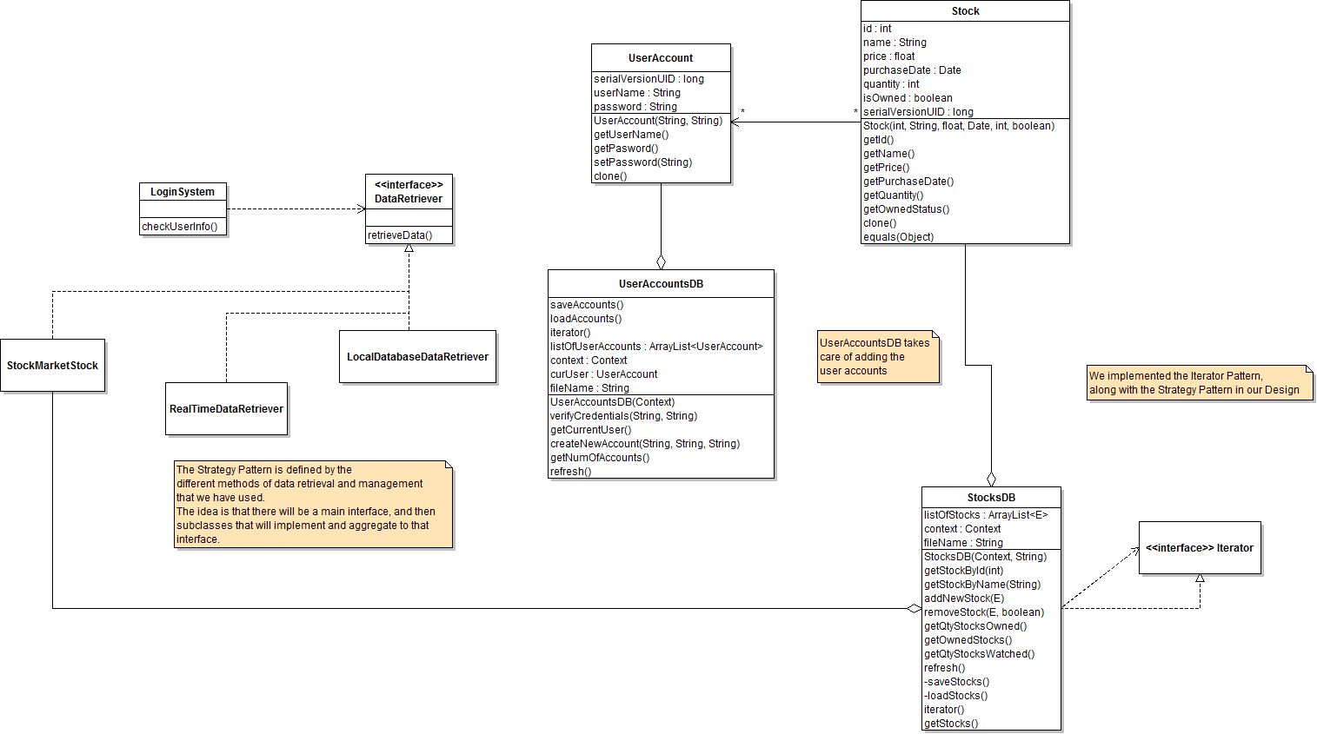

The Class Diagram below implements the interactions between the Watch list and Portfolio classes involved in the Decorator Pattern and Observer Pattern.

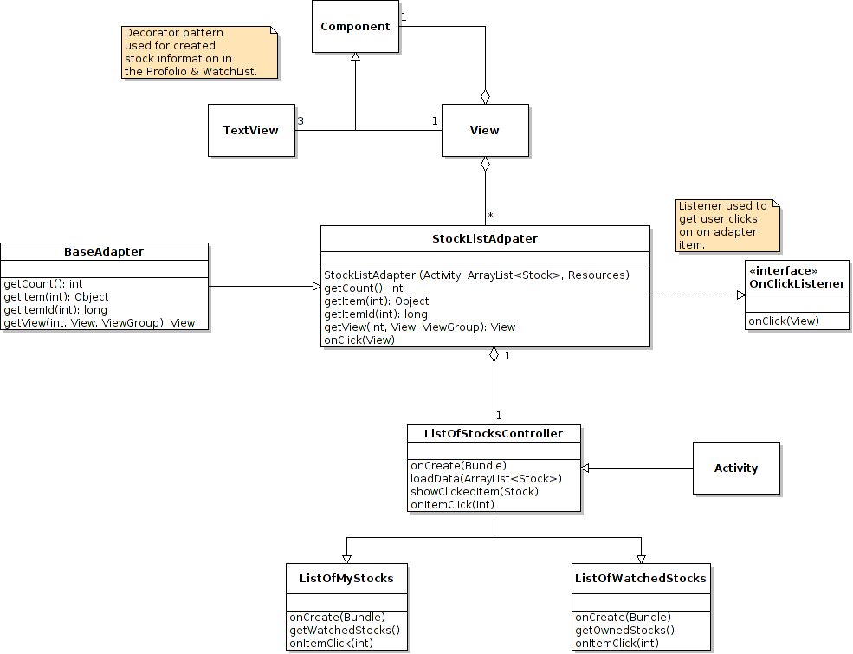

**Sequence Diagrams**

Sequence Diagram: Create New User

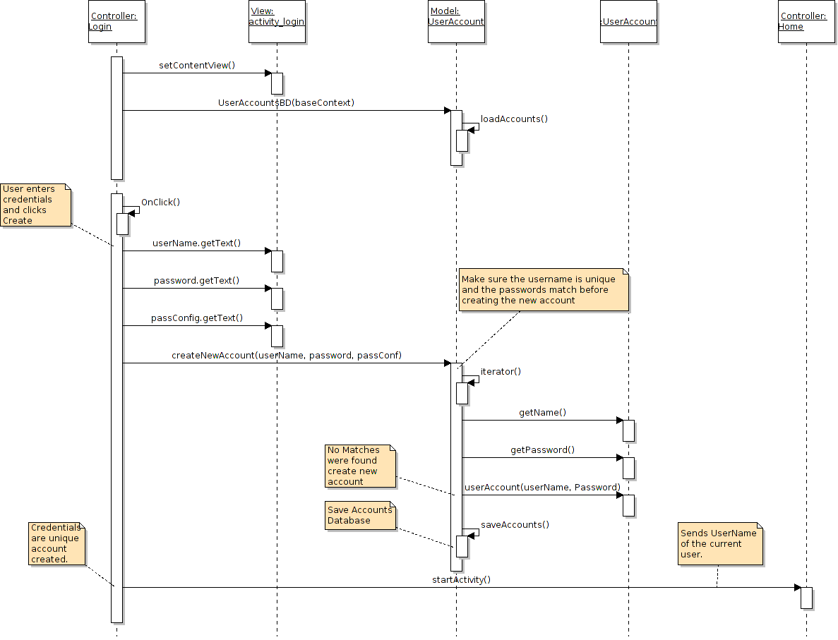

Sequence Diagram: Create New User Variation I: User Already Exists

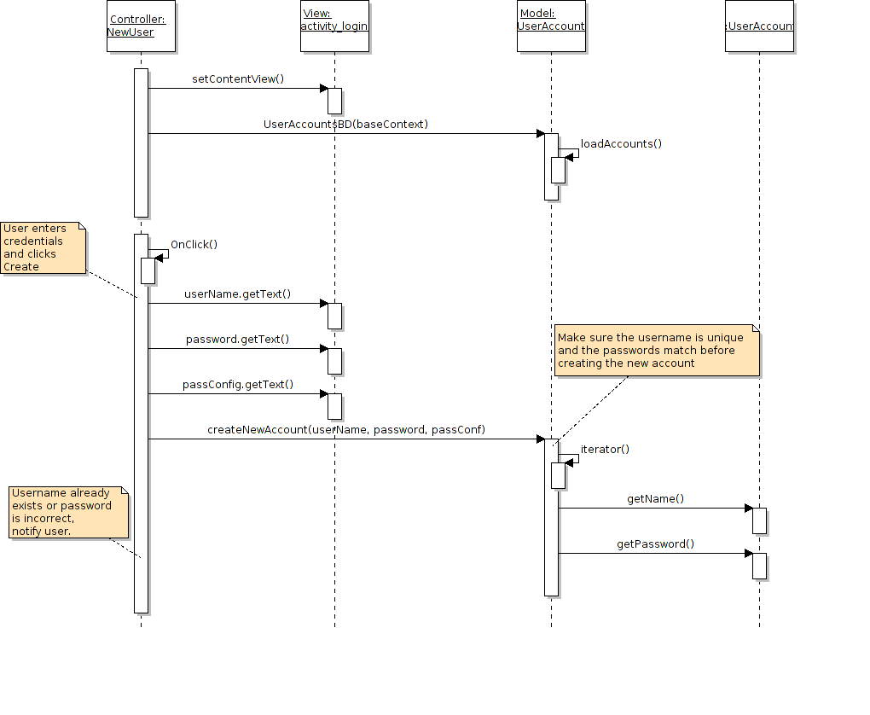

Sequence Diagram: Create New User Variation I: User Already Exists

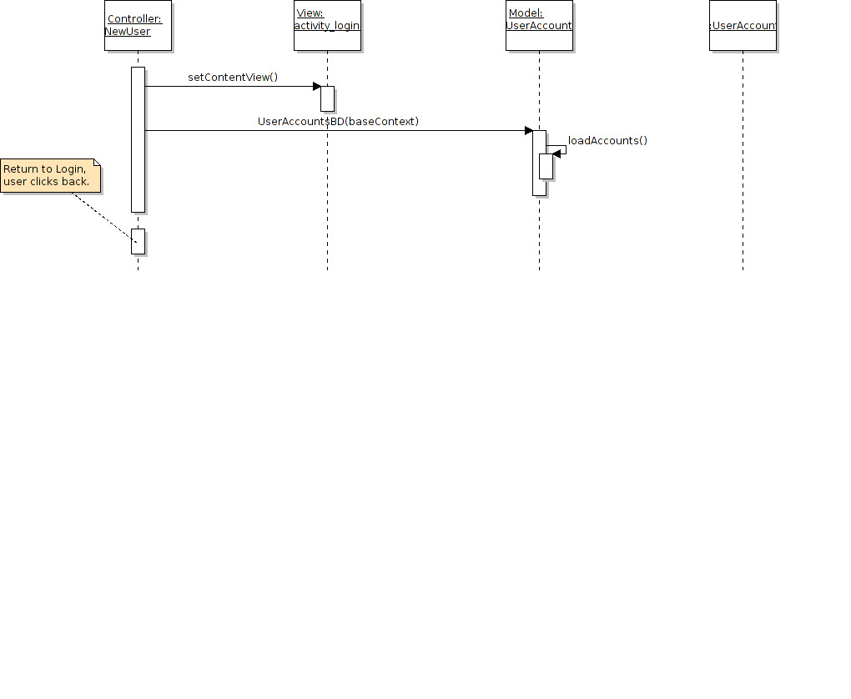

Sequence Diagram: User Login

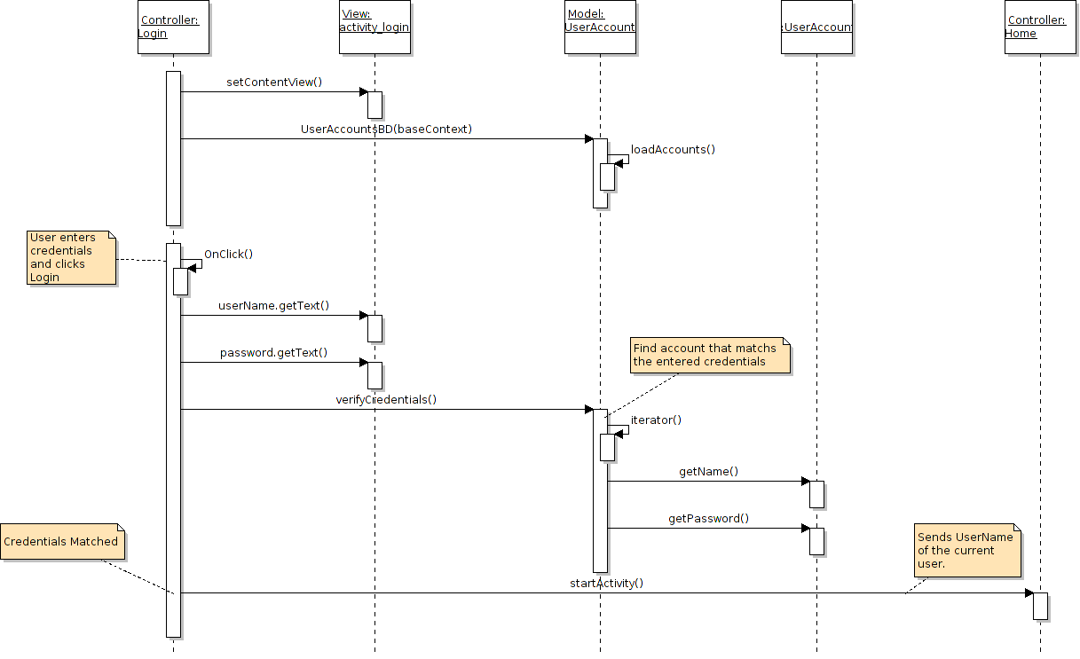

Sequence Diagram: User Login Variation I: Invalid Login

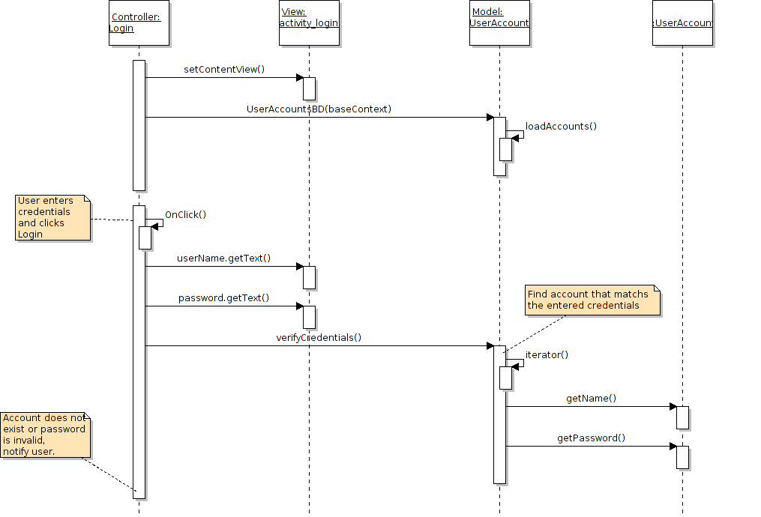

Sequence Diagram: User Login Variation II: New User

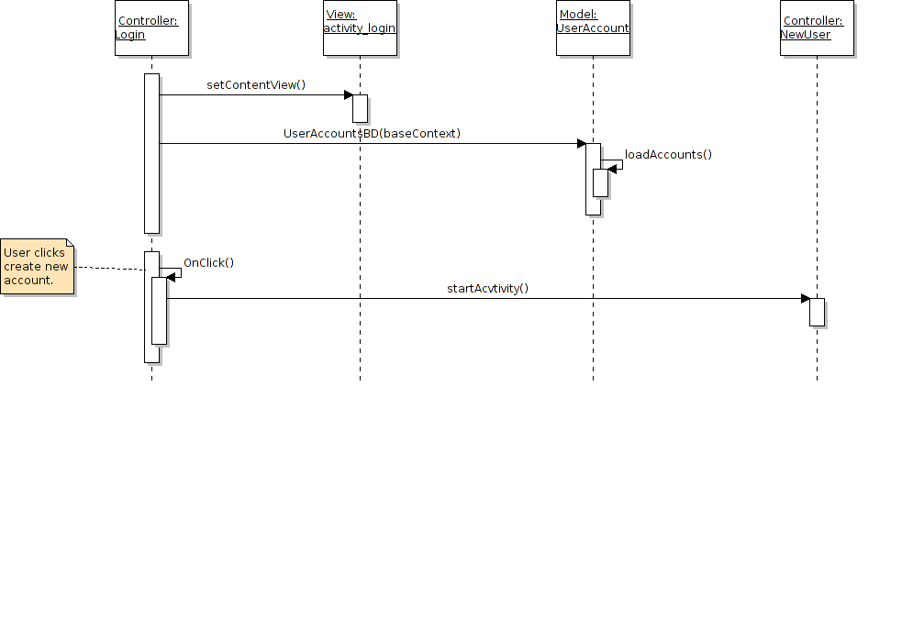

Sequence Diagram: Portfolio

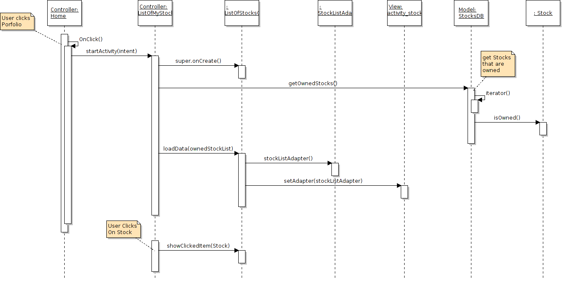

Sequence Diagram: Watched List

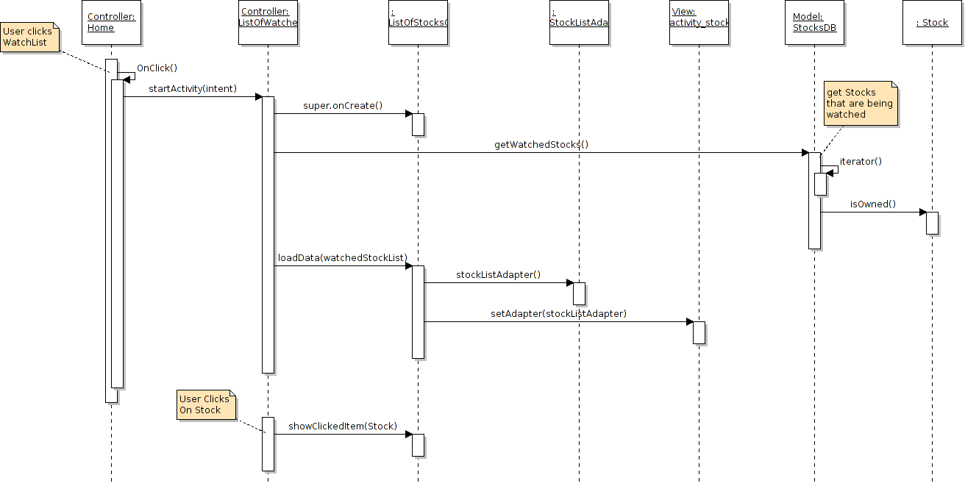

Sequence Diagram: Buy Stocks

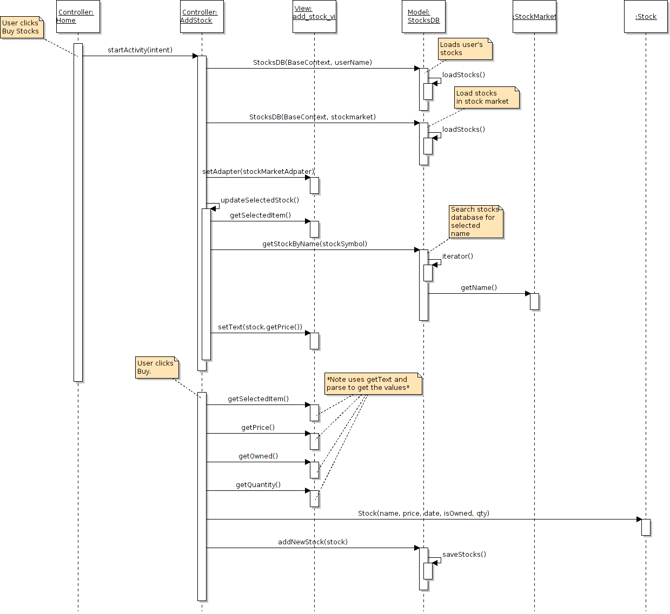

Sequence Diagram: Sell Stocks

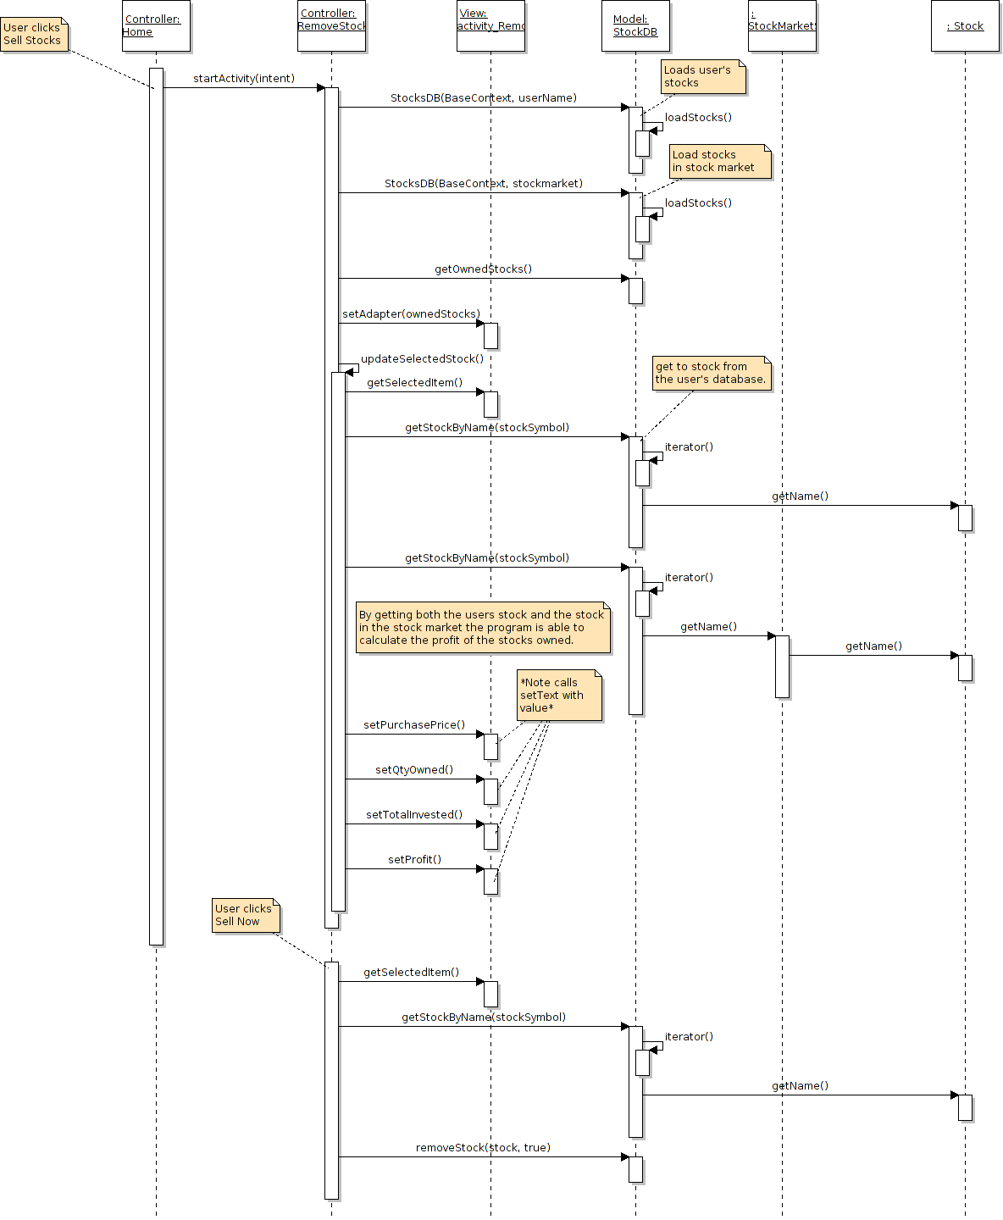

Sequence Diagram: Statistics

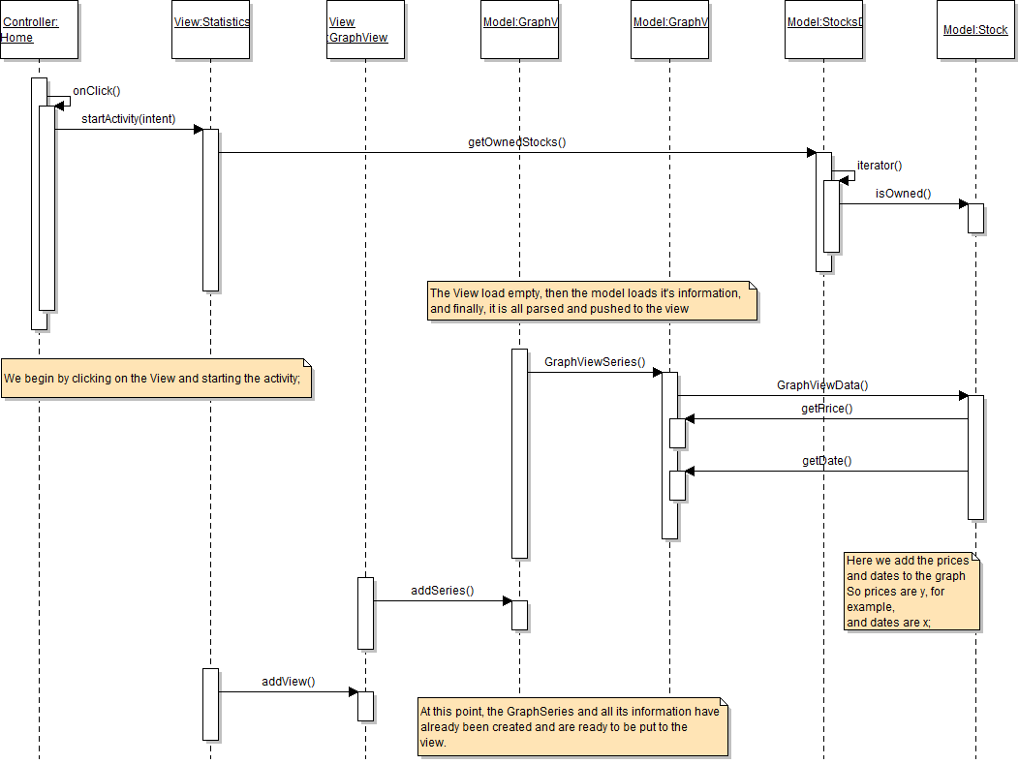

**State Diagram**

